DOCUMENTATION

There is comments in the code at the appropriate places.

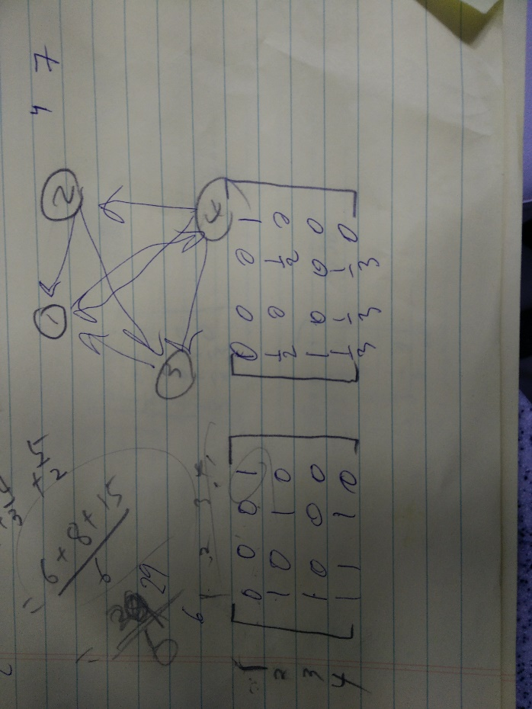also here is a  
**Step by step explaination.**

Read file

Save first line and split it to setup matrix size

//loop though every line of the data file

//split line into 2 ints

//set positions in matrix to 1  
every other position to 0

Calculate probability by looping the matrixes and for every 1 on a row add them together. To be able to then at that corresponding position in the new matrix add 1 divided by nbr off occurrences.

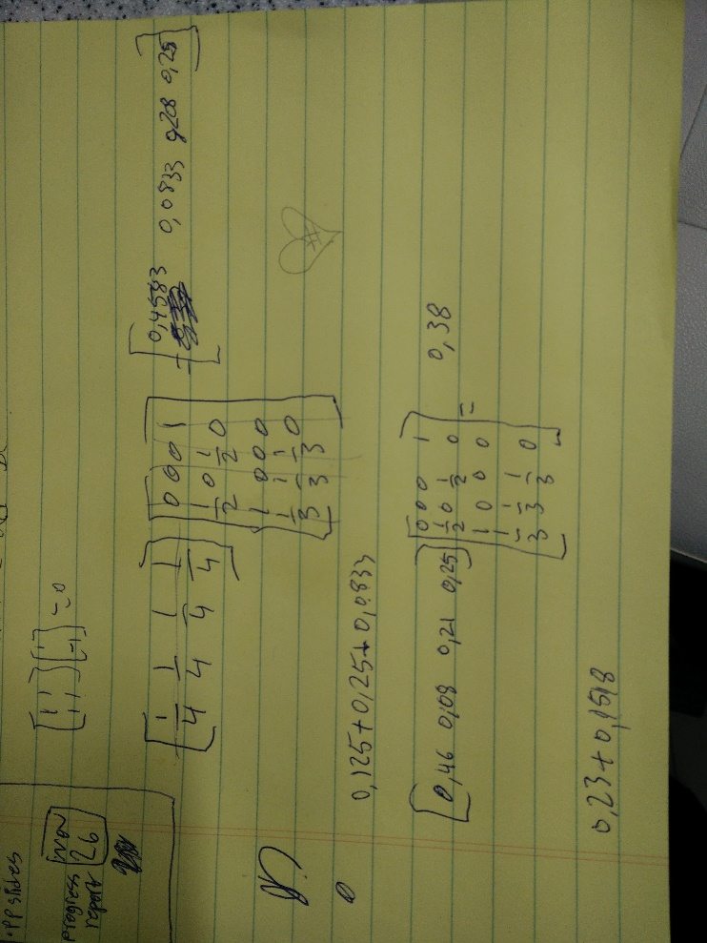Created power method array. And applied it to the matrix by using 4 loops.  
first one iterates the whole thing a 1000 times to get a better value  
Next two makes It possible to iterate though the whole 2 dimensional array (matrix). And the last one out side of the last two mentioned loops will set the res arrays values to the new values for multiplying in to the matrix. And set res array back to 0,

Figur calculatinng the probability matrix

Figur using power method

Ran the given algorithm to calculate the pageRanking

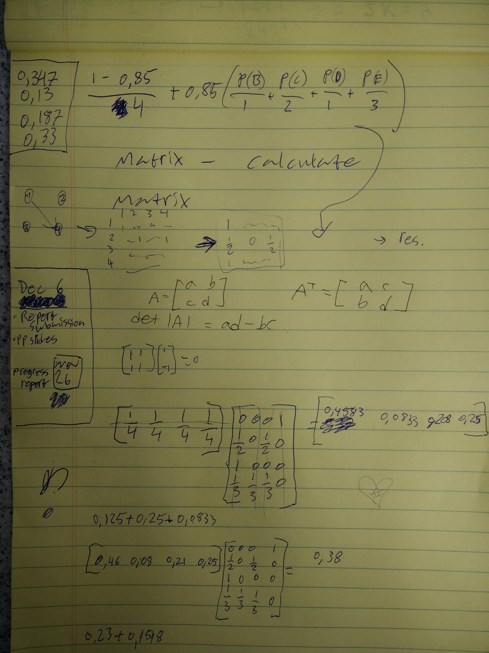

Figur 3figuring out how to apply the algorithm with the values from the matrix

Instructions how to run the code.

First you will need to modify the first line of code to make the program find the datafile.  
Change the directory.

Option one.

1. Open cmd

2. cd to folder containing java file.

C:\Users\username>cd c:\introcs\hello

C:\introcs\hello\>

3. compile the file

C:\introcs\hello\>javac HelloWorld.java

4. execute file

C:\introcs\hello\>java HelloWorld

5. enjoy.

Option two.

1.2 Other option start it in eclipse.